**Lab 4: Establishing Console connection and configuring Basic router settings with IOS CLI Topology**

Course Code - Course Name: - COMP4039 – Network Foundations

Program: T433 - Cybersecurity

Section: A

Term: - Winter 2024

Group Number: 06

Student Names - ID:

* Prabhjot Singh Sains – 101495218
* Rahul Patel - 101378458
* Jai Deep Rawat - 101503760
* M. Salmaan Mustafa Shah – 10151007

**Part A: Set up the topology and initialize the devices:**

1. Interlink all the components as shown in the topology diagram and turn on your devices.

a. What type of cable is used to connect the Ethernet interface on a host PC to the Ethernet interface on a switch?

Answer: Copper straight-through and Console Cable

b. What type of cable is used to connect the Ethernet interface on a switch to the Ethernet interface on a router?

Answer: Copper Straight-through

c. What type of cable is used to connect the Ethernet interface on a router to the Ethernet interface on a host PC?

Answer: copper cross-over and Console Cable

2. Connect the rollover console cable to the RJ-45 console port of the Router R1 and Switch S1 and start any available emulation program such as (Tera Term, putty or Hyper Terminal)

3. Initialize and reload the router and switch to clear any existing configuration using the following commands:

Router> enable

Router# erase startup-config

Router# reload

Switch> enable

Switch# delete vlan.dat

Switch# erase startup-config

Switch# reload

**Part B: Configure basic configuration and verify connectivity:**

1. Configure static IP address information on the PCs as shown in the topology diagram.

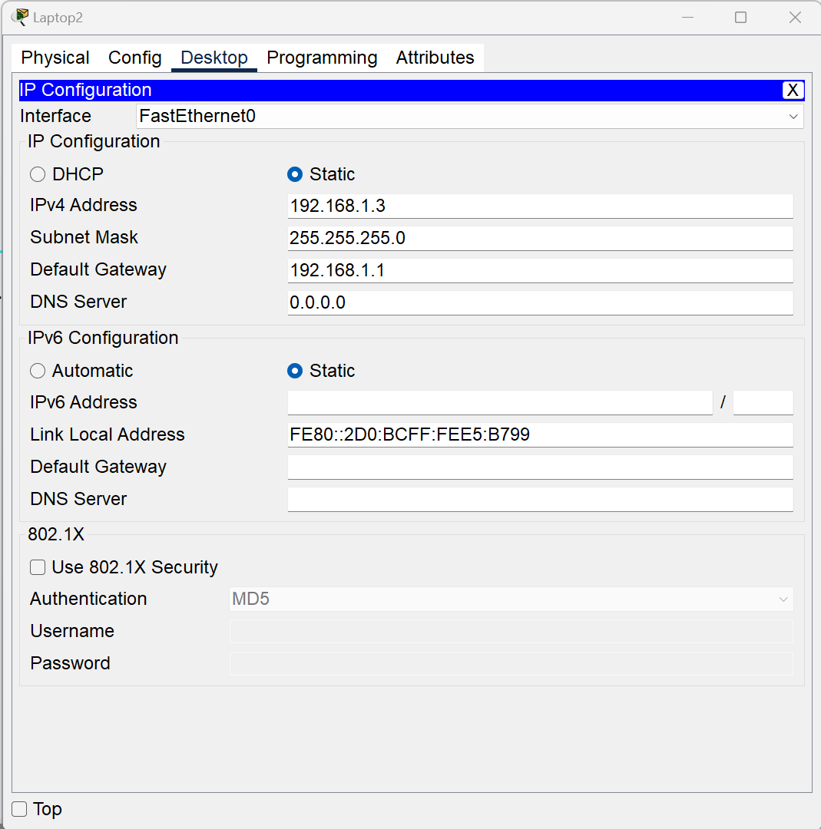

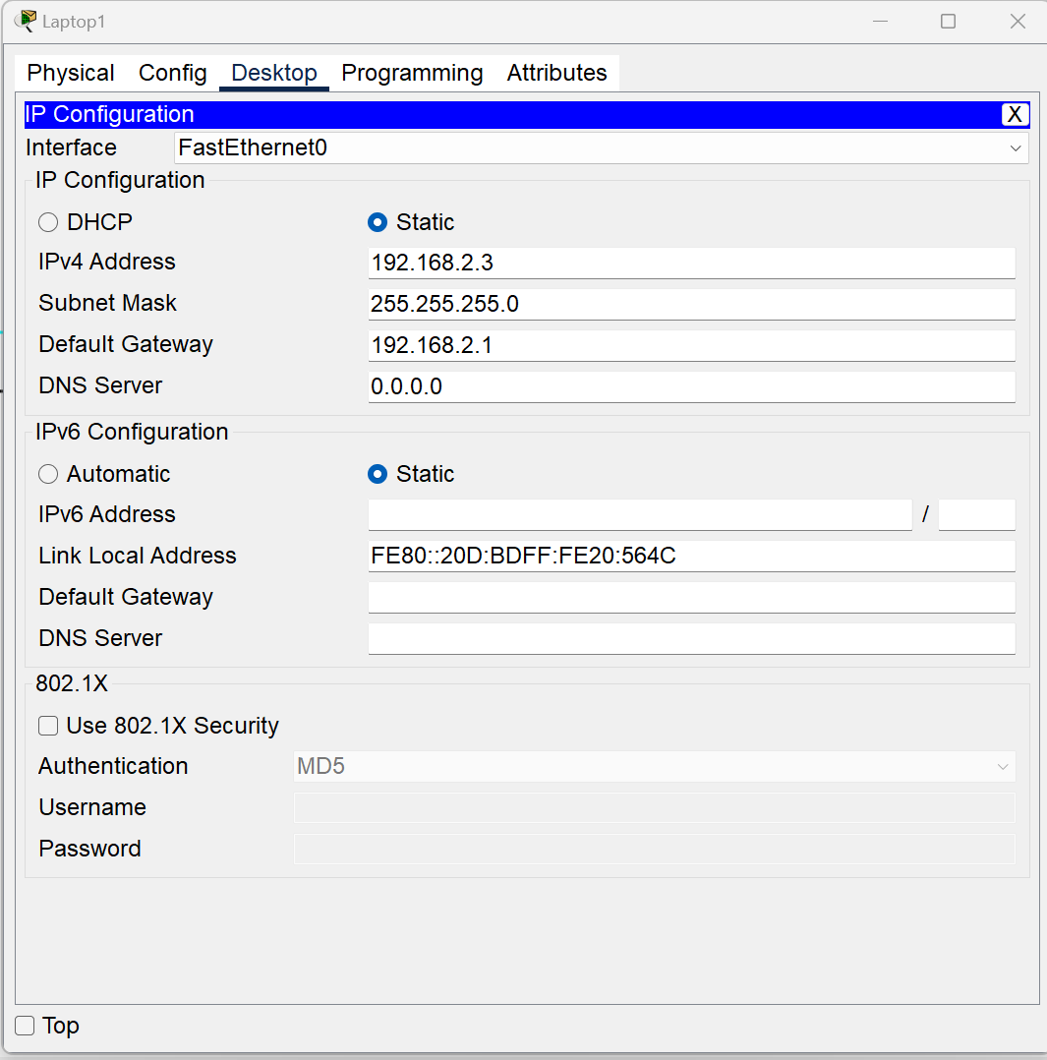

2. Configure and Verify Basic Settings for Router

Enter privileged EXEC mode and then configuration mode.

Router> enable

Router# configure terminal

Router(config)#

Use the hostname command to change the router name to R.

Router(config)# hostname R

R(config)#

Prevent unwanted DNS lookups.

R(config)# no ip domain-lookup

Enter local passwords: To prevent unauthorized access to the router, passwords must be configured.

R(config)# enable secret class

R(config)# line con 0

R(config-line)# password cisco

R(config-line)# login

R(config-line)# exit

R(config)#

Enter a login MOTD banner.

R(config)# banner motd # Unauthorized access is strictly prohibited and prosecuted to the full extent

of the law. #

R(config)# exit

R#

Configure an IP address and interface description. Activate both interfaces on the router.

R(config)# int g0/0

R(config-if)# description Connection to PC-A

R(config-if)# ip address 192.168.1.1 255.255.255.0

R(config-if)# no shutdown

R(config-if)# int g0/1

R(config-if)# description Connection to S

R(config-if)# ip address 192.168.2.1 255.255.255.0

R(config-if)# no shutdown

R(config-if)# exit

R(config)# exit

Save the configuration. Use the copy command to save the running configuration to the startup file on non-volatile random-access memory (NVRAM). R# copy running-config startup-config

3. Use the following show commands to verify your configurations.

R# show running-config ------------------ To display the running configuration file.

R# show startup-config ------------------ To display the start configuration file.

R# show ip interface brief -------------- To verify interfaces state (Up or Down)

R# show ip route ------------------------- To verify IP routing table.

4. Test the connectivity between PC1 and PC2, troubleshoot as necessary.

Use the command prompt (cmd.exe) window to verify the connectivity between PCs.

From PC-A Type >ping 192.168.2.3 and press Enter. Were the ping results successful? No

Answer: No, The reason the pings between the two networks failed was because we hadn't set up an IP route on the router.

From PC-B Type >ping 192.168.1.3 and press Enter. Were the ping results successful? Yes

**Part C: Display router information:**

1. Use show version command and answer the following:

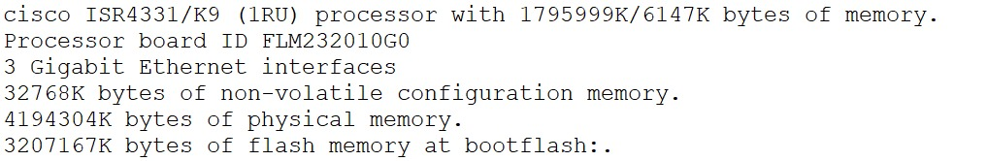

What is the name of the IOS image that the router is running and where it is located?

Answer: Cisco IOS Software [Everest], ISR Software (X86_64_LINUX_IOSD-UNIVERSALK9-M), Version 16.6.4, RELEASE SOFTWARE (fc3)

How much non-volatile random-access memory (NVRAM) does the router have?

Answer: 32768K Bytes of Non-volatile configuration memory.

How much Flash memory does the router have?

Answer: 3207167K bytes of flash memory at bootflash.